2025 – 2026 POST 16 OPTIONS/COLLEGE OPEN EVENTS
*Please see individual websites to book a place/for further details*
All Saints School, York | Wed 19 Nov 2025 | Sixth Form College offering a range of A levels & Vocational courses | www.allsaints.york.sch.uk  01904 647877
Archbishop Holgate’s School, York | Thurs 13 Nov 2025 | Sixth Form College offering a range of A levels & Vocational course | www.archbishopholgates.academy  01904 411341 | 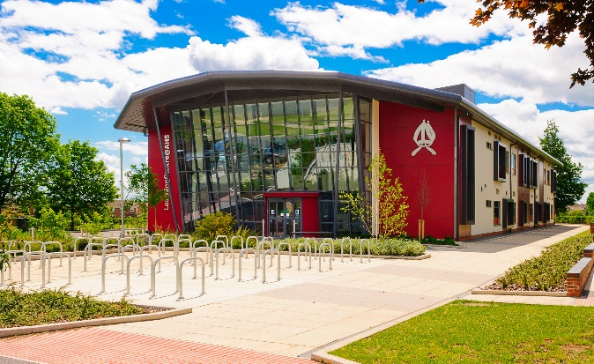
Askham Bryan College, York | Sat 18 Oct 2025  Sat 29 Nov 2025  Sat 24 Jan 2026  Sat 21 Mar 2026 | Specialist land-based college situated in York.  Variety of courses including agriculture; veterinary nursing; animal management; agricultural engineering; motor sport; floristry; sport; public services; apprenticeships | www.askham-bryan.ac.uk  01924 772277 | 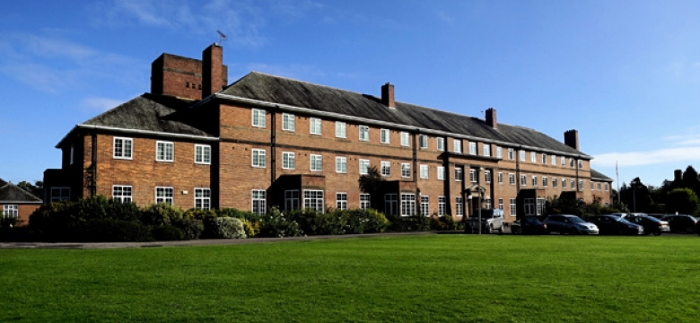
Bishop Burton College, Beverley | Sat 18 Oct 2025  Sat 29 Nov 2025  Sat 10 Jan 2026  Sat 07 Mar 2026  Tue 28 Apr 2026  Sat 20 Jun 2026 | Land based college, based just outside Beverley in East Yorkshire.  Variety of courses including agriculture; animal management; equine; sport; business; art & design; engineering; public services; apprenticeships. | www.bishopburton.ac.uk  01964 553000 | 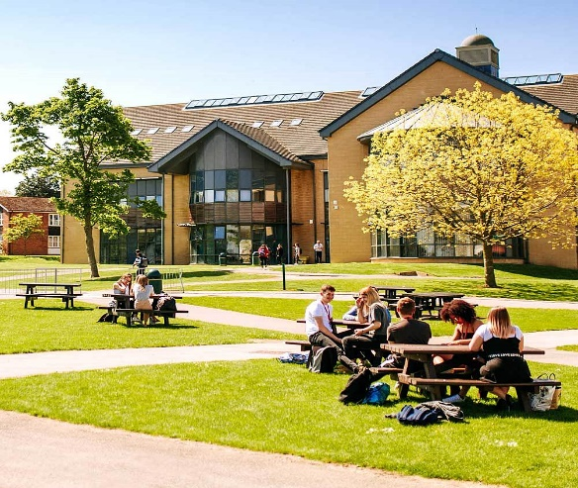
CAPA College, Wakefield | Sun 23 Nov 2025  Sun 18 Jan 2026 | Specialist Performing Arts College offering courses in Dance; Drama; Musical Theatre; Production Arts – Theatre, Film & Media | www.capa.college  01924 583737 | 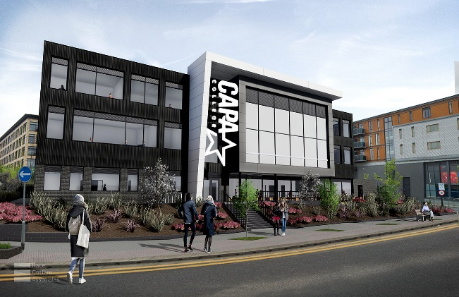
Derwent Training, Malton | Tue 10 Feb 2026 | Engineering Apprenticeship Provider | www.derwenttraining.co.uk  01653 697698 | 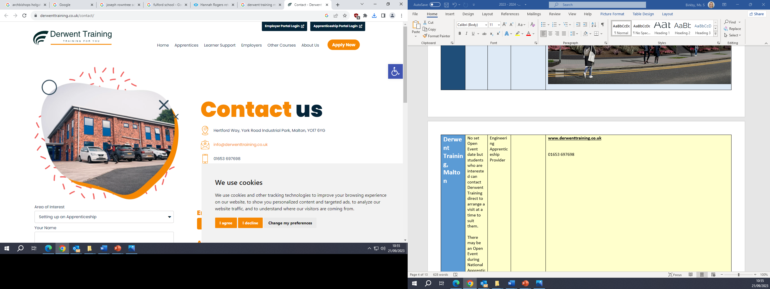
Fulford School, York | Thu 20 Nov 2025 | Sixth Form College offering a range of A levels & Vocational courses | www.fulford.york.sch.uk  01904 633300 | 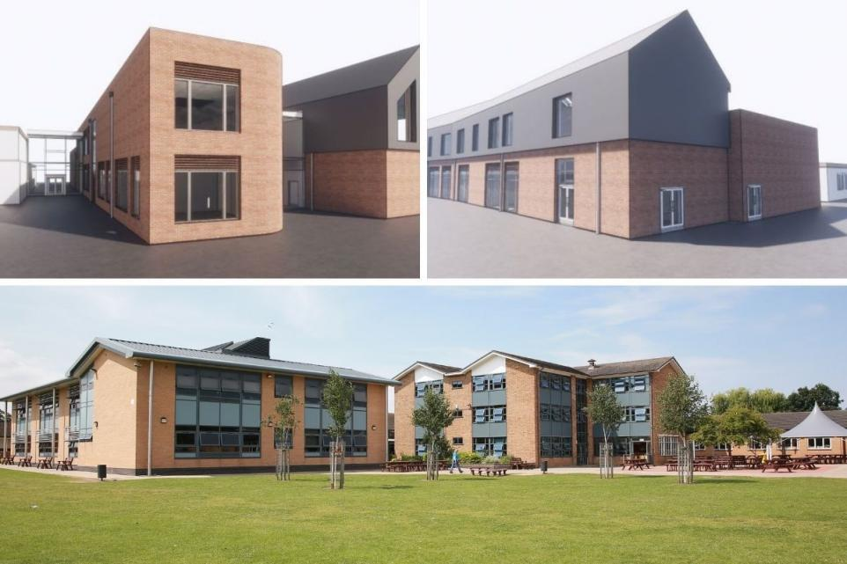
Huntington School, York | Tue 11 Nov 2025 | Sixth Form College offering a range of A levels & Vocational courses | www.huntingtonschool.co.uk  01904 752100 | 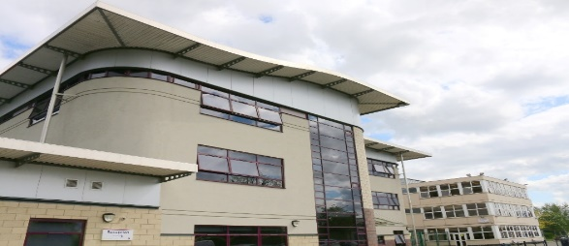
Joseph Rowntree School, York | Tue 18 Nov 2025 | Sixth Form College offering a range of A levels & Vocational courses | www.josephrowntree.co.uk  01904 552100 | 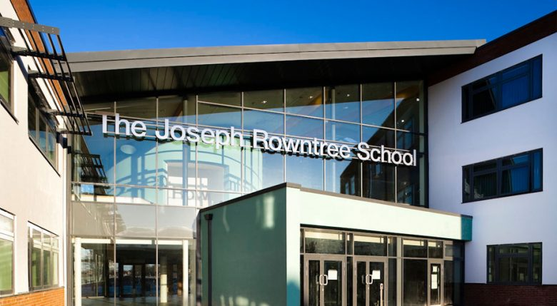
Leeds Arts University | Wed 1 Oct 2025  Sat 22 Nov 2025  Wed 28 Jan 2026  Wed 18 Mar 2026 | Specialist Art & Design facility based in Leeds City Centre. They offer the Extended Diploma in Creative Practice during which you will specialise in one of four pathways: Fashion & Textiles, Fine Art, Graphic Communication and 3D Design. | www.leeds-art.ac.uk  0113 202 8000 | 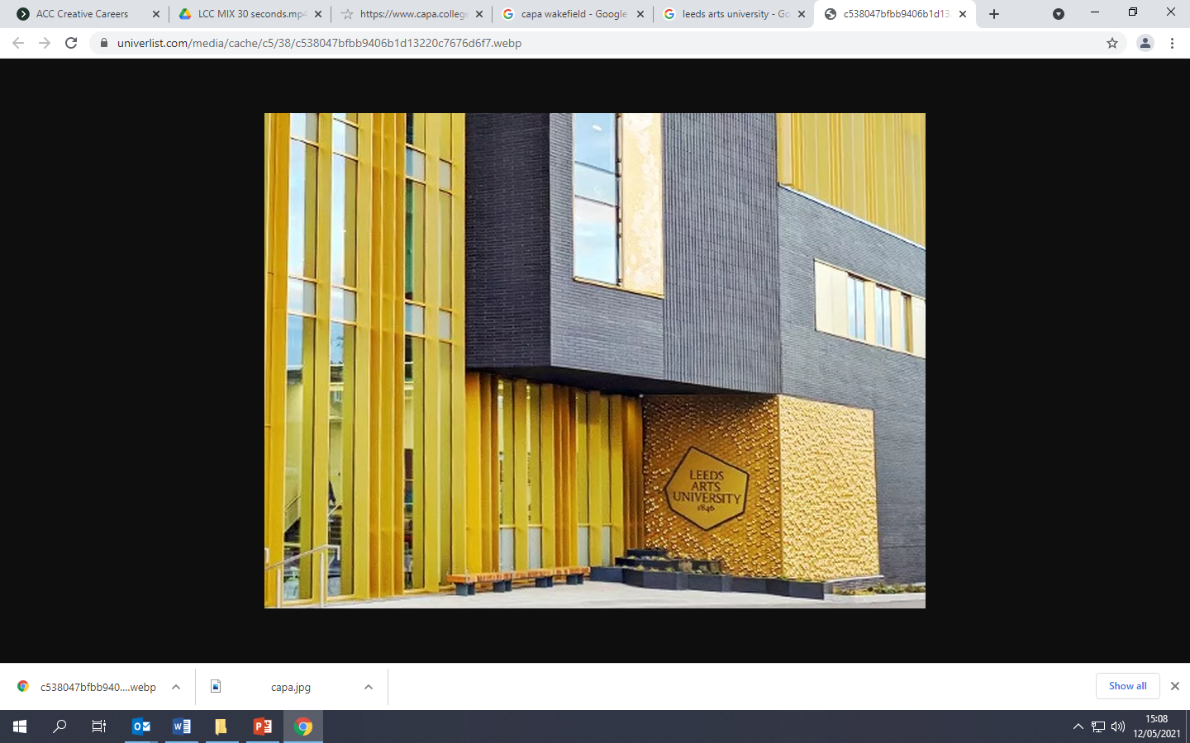
Leeds City College | Wed 15 Oct 2025  Wed 19 Nov 2025  Further events will be available later in the year – check website for details | Further Education College offering a range of A level and Vocational courses as well as apprenticeships. | www.leedscitycollege.ac.uk  0113 386 1997 | 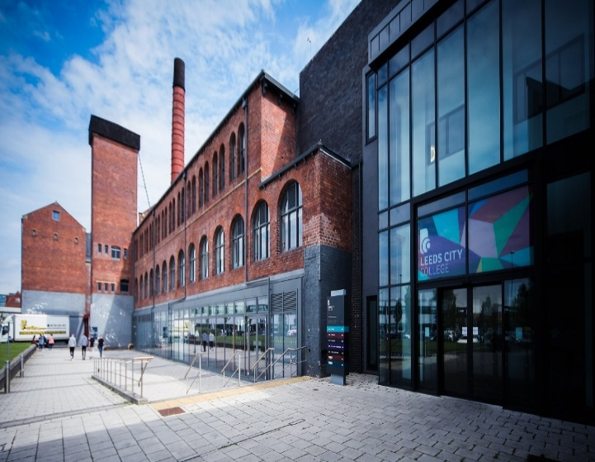
Leeds College of Building | Wed 15 Oct 2025  Sat 15 Nov 2025  Sat 28 Mar 2026 | The only specialist college in the UK dedicated to construction & the built environment.  Offer a vast range of construction related courses including all trades as well as courses such as quantity surveying, building and civil engineering, and apprenticeships. | www.lcb.ac.uk  0113 2226000/2226003 | 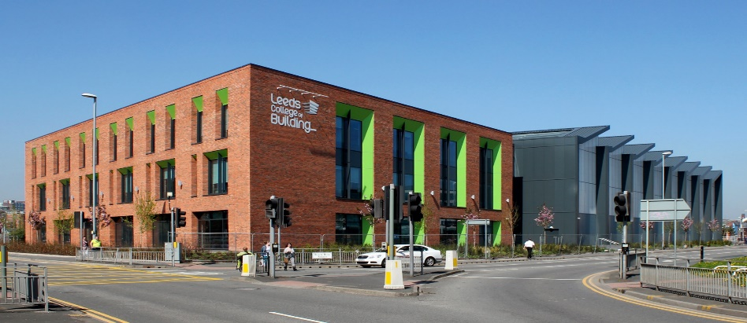
UTC Leeds | Thu 16 Oct 2025  Thu 11 Dec 2025  Thu 5 Feb 2026 | UTC Leeds, based in Leeds City Centre, is a specialist college focusing on engineering and advanced technology. They offer A level courses in Engineering, Maths, Sciences, Computer Science and DT Product Design. | www.utcleeds.co.uk  0113 353 0140 | 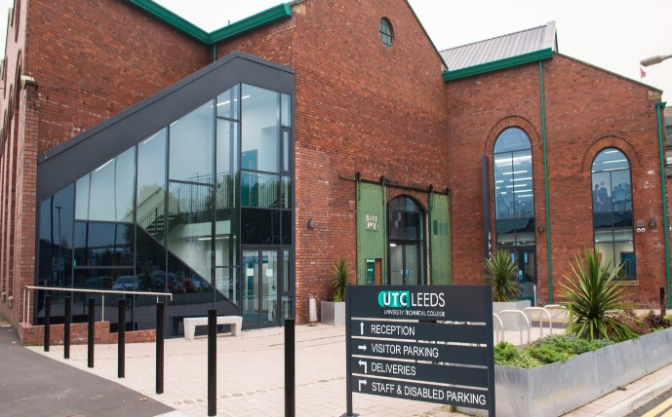
Selby College | Sat 18 Oct 2025  Wed 19 Nov 2025  Mon 9 Feb 2026  Wed 17 Jun 2026 | Further Education College offering a range of A level and Vocational courses as well as apprenticeships. | www.selby.ac.uk  01757 211 000 | 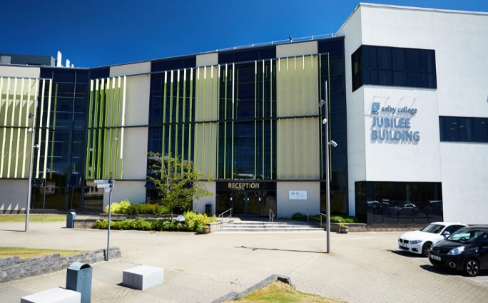
York College | Tue 7 Oct 2025  Sat 8 Nov 2025  Thu 20 Nov 2025  Thu 12 Feb 2026  Wed 29 Apr 2026 | Further Education College offering a range of A level and Vocational courses as well as apprenticeships. | www.yorkcollege.ac.uk  01904 770100 | 