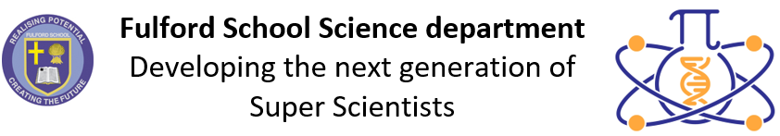 | Science Curriculum Overview  2025-2026

 | Key stage 3 |  |  | Key stage 4
 | Year 7 | Year 8 | Year 9 | Year 10 | Year 11
Half-term 1  1 Sept 25 –  24 Oct 25 | 7.0 Skills  7.1 Forces  7.5 Matter  7.8 Organisms | 8.0 Skills  8.1 Forces  8.5 Matter  8.8 Organisms | 9. B1 Cells  9. P1.1 Energy  9. P2.1 Electricity  9. C9 Atmospheric  Chemistry | 10. B2 Organisation  10. P1.2 Energy  10. P2.2 Electricity  10. C3 Quantitative  Chemistry  10. C4 Chemical  Changes | 11. P6 Waves  11. B5 Homeostasis  11. C7 Organic  Chemistry
Half-term 2
3 Nov 25 –
19 Dec 25
Half-term 3  5 Jan 26 –  13 Feb 26 | 7.2 Electricity  7.6 Reactions  7.9 Ecosystems | 8.2 Electricity and  Magnetism  8.6 Reactions  8.9 Ecosystems  7.7 Space | 9. P2.1 Electricity  9. C1 Atomic Structure  and Periodic Table  9. B1 Cells | 10. C4 Chemical  Changes  10. C5 Energy Changes  10. B3 Infection and  Response  10. P5 Forces | 11. P7 Electromagnets  11. B6 Inheritance  11. C8 Chemical  Analysis  11. C10 Using  Resources
Half-term 4
23 Feb 26 –
27 Mar 26
Half-term 5  13 April 26 –  22 May 26 | 7.3 Energy  7.4 Waves  7.10 Genes | 8.3 Energy  8. 4 Waves  8.7 Atmosphere  8.10 Genes | 9. C2 Structure and  Bonding  9. P3 Particle Model of  Matter  9. B4 Bioenergetics | 10. C5 Energy Changes  10. C6 Rate and Extent  of Chemical Change  10. P5 Forces  10. B5 Homeostasis | 11. C10 Using  Resources  11. B7 Ecology  11. P7 Electromagnets  11. P8 Space  (Physics only)
Half-term 6
1 June 26 –
20 July 26

