Fulford School
Fulfordgate, Heslington Lane, Fulford, York. YO10 4FY
T: 01904 633300 E: office@fulford.york.sch.uk W:www.fulford.york.sch.uk

13 January 2020

Dear Parents of Year 11 Students,
As we approach the final run-in towards examinations, I am writing to let you know about some of the support that will be in place for Year 11 students.
Revision Sessions
A comprehensive programme of Year 11 revision sessions will take place across departments at lunchtimes and after school. Details of this programme will be published in February and sessions will begin shortly after that. Please encourage your child to attend these sessions wherever possible.
Resources to Support Revision
Attached to this letter is a list of resources which have been recommended by Curriculum Leaders across the school and which could support your child’s preparation for the summer examinations. The ISBN number of recommended books has been provided, in order that you can locate these more easily. Where recommended websites require a password in order to access them, this has also been provided.
A number of departments produce their own revision guides which will be issued to students over the course of the next term. These will also be available on the school VLE website and the recommended guides should be seen as supplementary to this.
An increasing number of departments use YouTube videos for revision purposes. In order to support students’ independent study, we have made the decision to allow Year 11 students to access these within school. As with all IT facilities, any students found to be using YouTube inappropriately will be sanctioned in line with the school policy.
Revision Skills Session and Progress Reviews
During the morning of Wednesday 12th February, the day of the Year 11 Progress Reviews, an external organisation called Learning Performance will be delivering a two-hour study skills session to all Year 11 students in order to support the process of effective revision. There will also be an evening presentation for parents in the main hall at 6:00pm that day, details of which will be sent home shortly.
Progress Reviews take place on the afternoon of Wednesday 12th February. Again, further details relating to these will be sent home shortly.

Additional Mock Examinations and Practice Paper Questions
All Year 11 students will sit a second series of mock examinations across a range of subjects immediately after February half term. The timetable for these additional mock examinations is being sent home alongside this letter. The final grade in the majority of the newly reformed GCSEs is determined exclusively by the results of the examinations. It is important, therefore, that we offer students as much support as possible in practising these papers before the final examinations.
Practice paper questions will also be made available to students across all subject areas and these form a crucial part of students’ preparation for the final examinations.
Supervised Access to B1 before School and at Lunchtime.
From now until the summer examinations, Year 11 students will be able to access the computer room B1 between 7.30am and 8.30am and between 1.30pm and 2:00pm each day. Year 11 students can use this quiet work room in order to access online resources, print out past papers or complete independent revision.

The next few months will obviously play an important part in shaping your child’s future. As ever, we appreciate your support in encouraging him/her to make the most of the resources available.
Yours faithfully

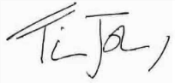

Mr T Johnson
Deputy Headteacher
(Curriculum and Achievement)

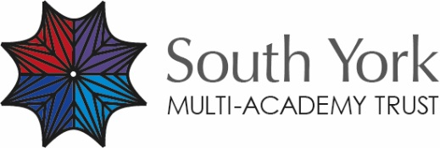
The South York Multi-Academy Trust.
Registered address: Fulfordgate, Heslington Lane, Fulford, York YO10 4FY.
A charitable company limited guarantee registered in England and Wales.
(company number:11082297)

