Fulford School
Fulfordgate, Heslington Lane, Fulford, York. YO10 4FY
T: 01904 633300 E: office@fulford.york.sch.uk W:www.fulford.york.sch.uk

10th January 2020

Dear Parents/Carers of Year 8 students,
We are currently in the process of a curriculum review, the outcomes of which will be finalised at a full governing body meeting on Tuesday 28 January. This means that the Year 8 options evening which is scheduled to take place on Monday 20 January will longer take place.
The two Year 8 parents’ evenings will go ahead as scheduled:
- E half on Thursday 30 January
- H half on Tuesday 4 February
We will communicate the outcomes of the curriculum review to students and parents on Wednesday 29 January, in advance of these parents’ evenings.
Yours faithfully,
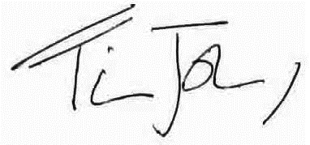
Mr T Johnson
Deputy Headteacher
Curriculum and Achievement

The South York Multi-Academy Trust.
Registered address: Fulfordgate, Heslington Lane, Fulford, York YO10 4FY.
A charitable company limited guarantee registered in England and Wales.
(company number:11082297)

