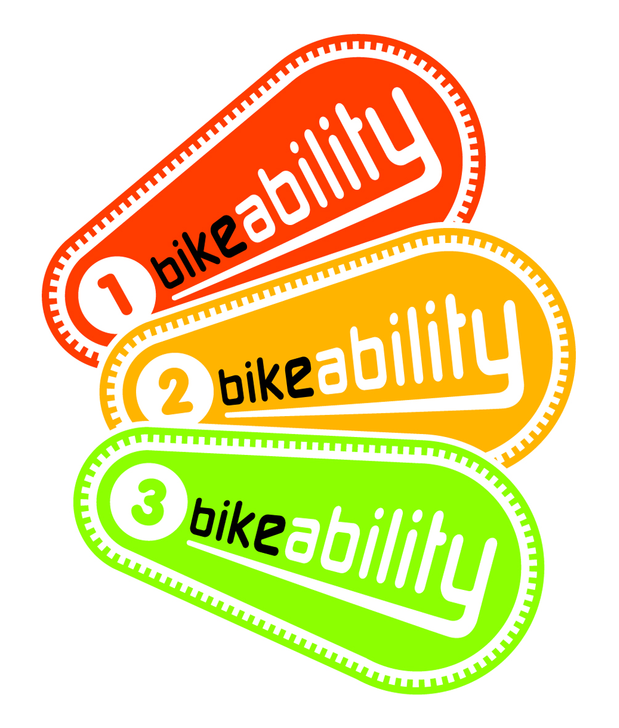

school logo goes here before saving as pdf.

Dear Parent

If you would like your child to take part in a City of York Council Bikeability Level 3 Cycle Training Course, please see the below information.

Bikeability training takes place during school time. Level 3 training usually runs for 2 hours. Your child will be trained on roads near to the school, which have been assessed for their safety.

The cost of training for Level 3 £8.40. Please make cheques payable to school. If you are in receipt of free school meals the cost is free. Please complete the consent form and return to the school.

Please note the following important information which includes details about the level your child can achieve and the circumstances in which your child can be refused training:
- Bikeability is outcome based.
- For those children who do not meet all the outcomes extra tuition can be bought. Please see contact details.
- All those taking part receive a certificate and a badge.
- Only children with roadworthy bikes – as assessed by the trainer will be trained.
- Any child who is not appropriately dressed may be refused training.
- A high viz vest will be provided for the duration of the course.
- The wearing of helmets is determined by the parent or by school policy.
- For those children who do not meet the outcomes because they missed a session, e.g. through illness, extra tuition can be bought. Please see contact details.
- The start of the session will cover all aspects of Level 2 training. This will include cycle checks and an assessment of riding skills. Participants MUST reach the required standard in order to proceed to the Level 3 sessions that follow.

Bikeability is the Cycling Proficiency Test for the 21st century. To get their Bikeability award, children will be instructed on how to ride their bikes to the Government-approved National Standard for Cycle Training. The standard has been developed by over 20 organisations and is maintained by the professional body for cycle training, the Cycle Training Standards Board. Further information can be found on www.bikeability.org.uk
--------------------------------------------------------------------------------------------------------------------------

City of York Basic Cyclist Training (Level 3) Parent/Guardian Consent Form

The school will advise the dates of training. Don’t forget to sign the reverse of this sheet!!

Your child’s name: __________________________________________________________
Date of Birth ___________________________________________________
HomeAddress:________________________________________________________________________________________________________________________________________
_________________________________________________________________________
School: ____________________________________________________________
Your name: _________________________________________________________
Daytime telephone number: ___________________________________________
E-mail: ____________________________________________________________
The cost of Level 3 training is £8.40 Please make cheques payable to school
We qualify for FREE cyclist training (for families who receive free school meals)
please circle Y or N ?
Do you go cycling with your child (named above)? Y or N?

Before you child arrives you should check their bike. As instructors, we reserve the right to refuse to take out any child whose cycle is not the correct size or is considered un-roadworthy. You should check:

- Bicycle with saddle and handlebars adjusted to the correct height
- Functioning brakes
- Pumped up tyres with no punctures

It is also important that your child is dressed appropriately for the training. Think about the weather – if it’s raining or cold please ensure that your child has adequate warm waterproof clothing with them. High-visibility vests will be provided for each child on the day.

After the session, children are encouraged to practice what they have learnt and your support in this is also encouraged.

Bikeability is not just about teaching children to ride a bike and equipping them with the necessary skills and knowledge needed to ride a bike safely throughout the rest of their life. It’s also about introducing them to cycling as an everyday activity – an alternative mode of transport, an enjoyable pastime, which brings a healthier lifestyle and ultimately lots of fun. Bikeability will give children a life skill that once they’ve learnt, they will never forget.

If you have any questions about the course please do not hesitate to contact us on 01904 551646 or email cycle.training@york.gov.uk. You can also visit the Bikeability website – www.bikeability.org.uk Parents are welcome to observe the training at all times.

Yours faithfully,

Shaun Wilkinson
Road Safety Training Coordinator
City of York Council
West Offices
Station Rise
York
YO1 6GA
01904 551646
shaun.wilkinson@york.gov.uk
----------------------------------------------------------------------------------------------------------------------------

Please tell us about any medical conditions that your child may have? e.g. asthma, epilepsy, sight,hearingetc_____________________________________________________________
PLEASE READ AND SIGN THE FOLLOWING DECLARATION.
PLEASE RETURN THE CONSENT FORM TO YOUR CHILD’S SCHOOL.

I have read and understood the letter to parents. I will check my child’s cycle to ensure that it is roadworthy and I am responsible for it being roadworthy for the session.
I understand that my child will be trained on the public road (wherever possible), will wear a high visibility top and will be supervised at all times.
I understand CYC leaves the decision about wearing a cycle helmet entirely up to the school or parent / carer. CYC is not responsible for any outcomes relating to this.
Please see websites www.bhit.org or www.bhsi.org or www.cyclehelmets.org for further information.
I understand Bikeability is outcome based and my child may require further training to get a badge.

Signed _______________________________________________ Date_________
We also offer training for children, adults and families. If you are interested in finding out more about other types of training, either call direct on 01904 551646 or e-mail cycle.training@york.gov.uk

